DOKUZ EYLUL UNIVERSITY

Faculty of Engineering

Electrical and Electronics Engineering

**EED 1005 Introduction to Programming Laboratoary#4**

Student Name : Yavuz BALI Number:2014502021

**Preliminary Work:**

**Task 1:**

#include<math.h>

#include<stdio.h>

#include<stdlib.h>

int main()

{ int a,b,sum;

printf("Please enter a value for a :"); //ask the first integer from user keyboard

scanf("%d",&a); // scan the first integer to address of a

printf("Please enter a value for b :"); // ask the second integer from user

keyboard

scanf("%d",&b); // scan the second integer to address of b

sum=a+b; // sum is equal to a+b

if(sum>0) // if condition for compare the sum with 0 for negative,positive or equal

{

printf("Sum of a and b is positive");

}

else if(sum=0)

{

printf("Sum of a and b is equal at 0");

}

else

{

printf("sum of a and b is negative.");

}

return 0;

}

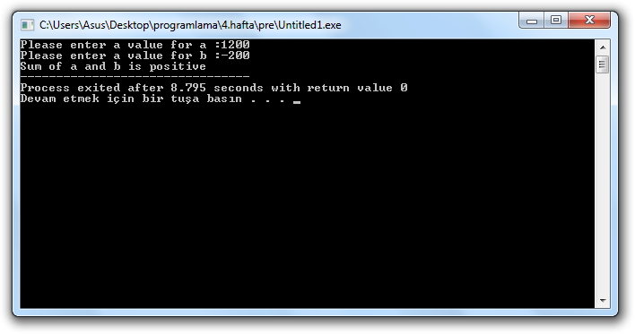

**Task 2:**

#include <stdio.h>

#include <stdlib.h>

int main() {

int grade;

printf("Please enter the grade: "); //ask a number from user keyboard

scanf("%d",&grade); //scan the number to address of grade

printf("\n");

switch(grade>=90){ //first switch case statement for compare the grade

case 1: printf("%d=AA\n",grade); break;

case 0:

switch(grade>=85){ //second switch case statement for compare the grade

case 1: printf("%d=BA\n",grade); break;

case 0:

switch(grade>=80){ //third switch case statement for compare the grade case 1: printf("%d=BB\n",grade); break;

case 0:

switch(grade>=75){ //fourth switch case statement for compare the grade

case 1: printf("%d=CB\n",grade); break;

case 0:

switch(grade>=70){ //fifth switch case statement for compare the grade

case 1: printf("%d=CC\n",grade); break;

case 0:

switch(grade>=65){ //sixth switch case statement for compare the grade

case 1: printf("%d=DC\n",grade); break;

case 0:

switch(grade>=60){ //seventh switch case statement for compare the grade

case 1: printf("%d=DD\n",grade); break;

case 0:

switch(grade>=55){ //eightht switch case statement for compare the grade

case 1: printf("%d=FD\n",grade); break; }

default: printf("%d=FF\n",grade); break; // default if these 7 statement is false,follow out the condition

}

}

}

}

}

}

}

return 0;

}